**Object Oriented Programming Lab**

**Fall’20**

**Department of Computer Science**

|  |  |
| --- | --- |
| **STUDENT NAME** | Abdullah Muhammad Ibrahim |
| **STUDENT ID** | SP20-BSCS-0027 |
| **SECTION** | AM |
| **ASSIGNMENT NO.** | 02 |
| **DUE DATE** | 16/10/2020 |
| **SUBMITTED ON** | 15/10/2020 |

***Mohammad Ali Jinnah University***

**Object Oriented Programming Lab**

**Fall’20**

**Question 1/Task 1:**

Write a Java program to print an int, a double and a char on screen.

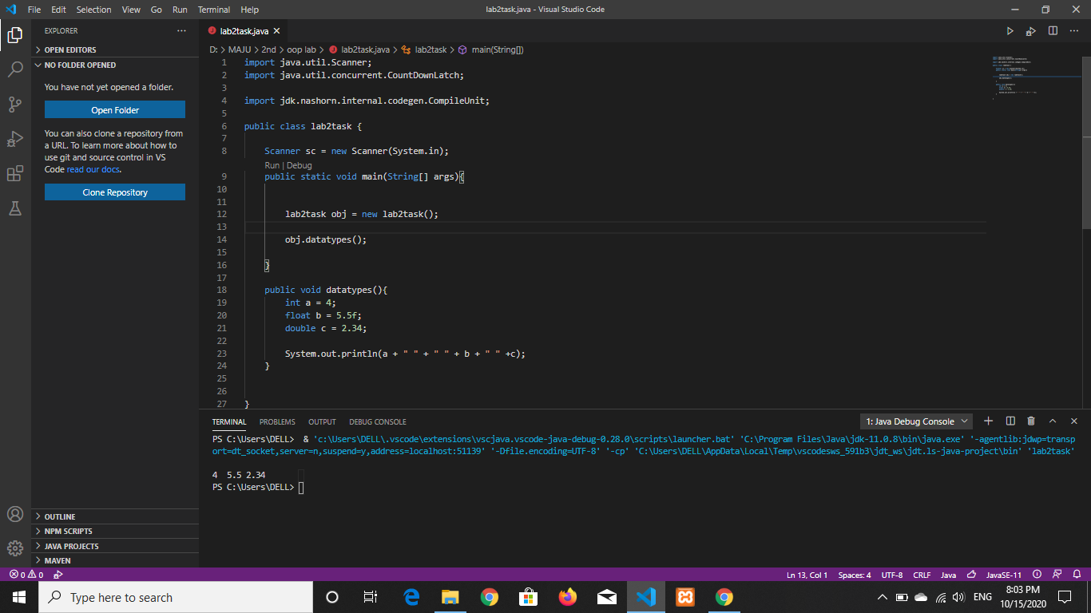

**Question 2/Task 2:**

Write a program to print the area of a rectangle of sides 2 and 3 units respectively.

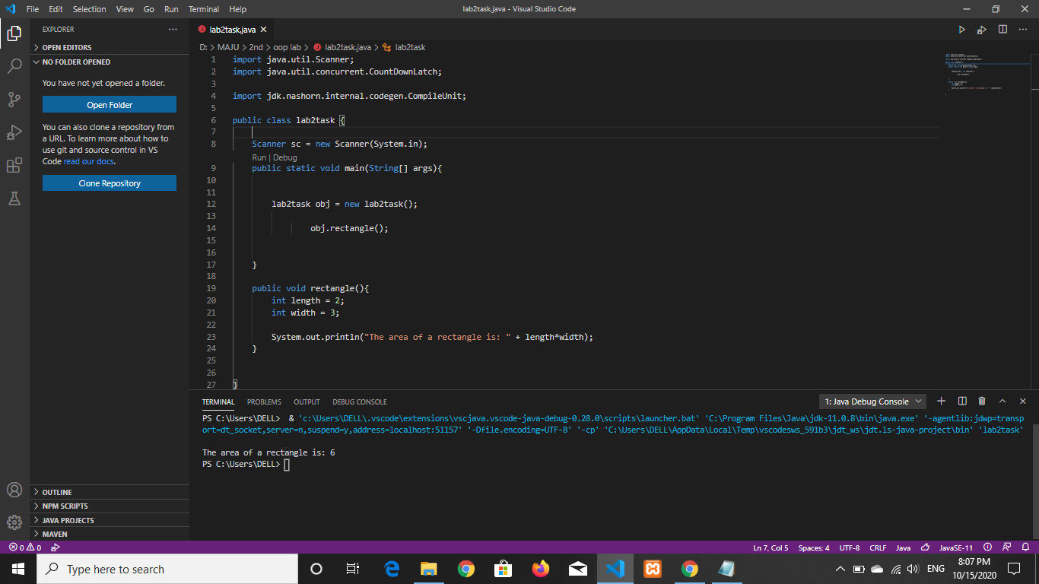

**Question 3/Task 3:**

Write a program to print the product of the numbers 7.2 and 6.

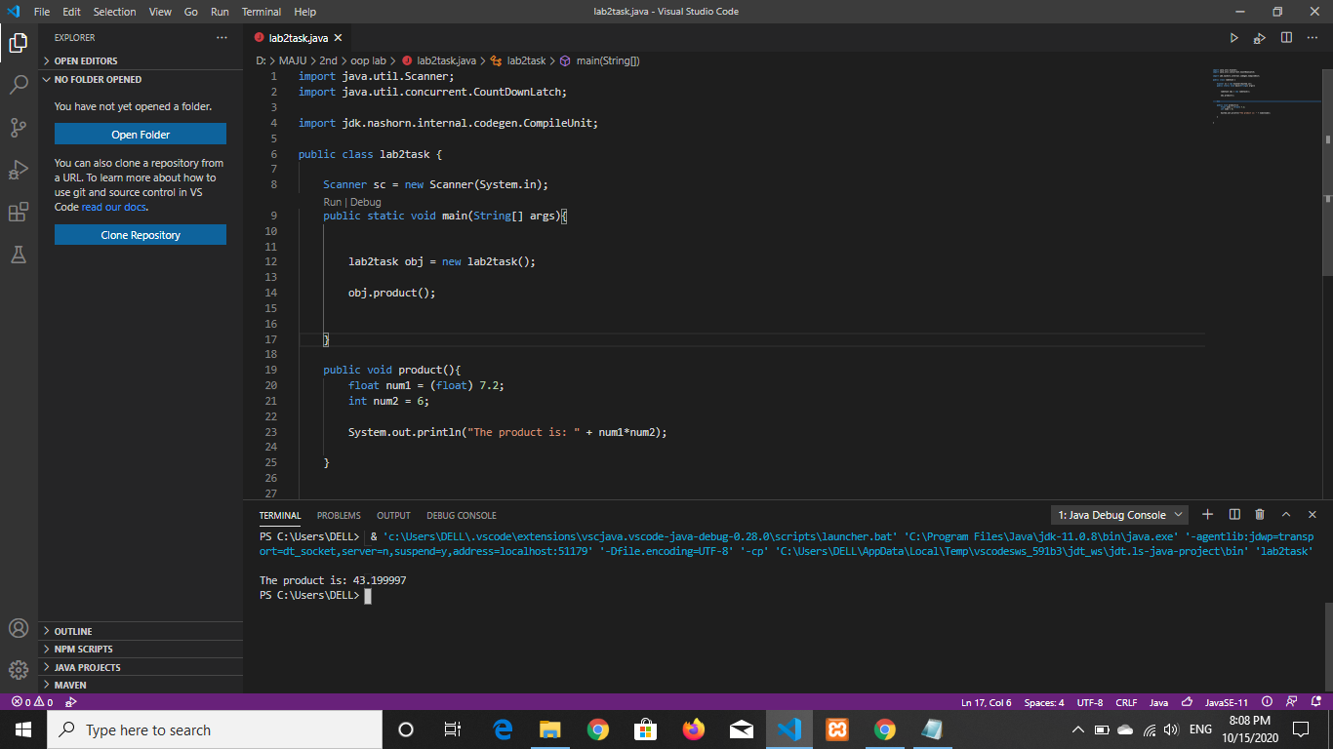

**Question 4/Task 4:**

Print the ASCII value of the character ‘b’.

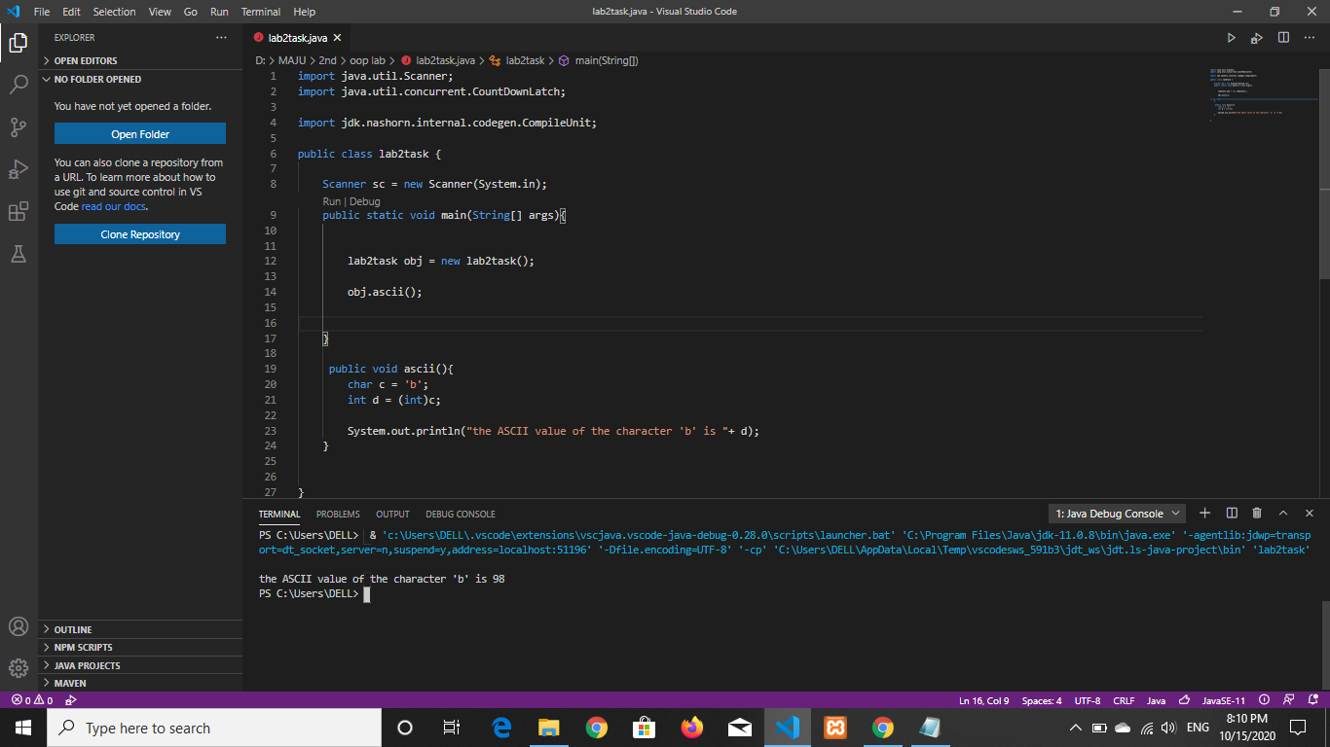

**Question 5/Task 5:**

Write a program to assign a value of **100.235** to a double variable and then convert it

to int.

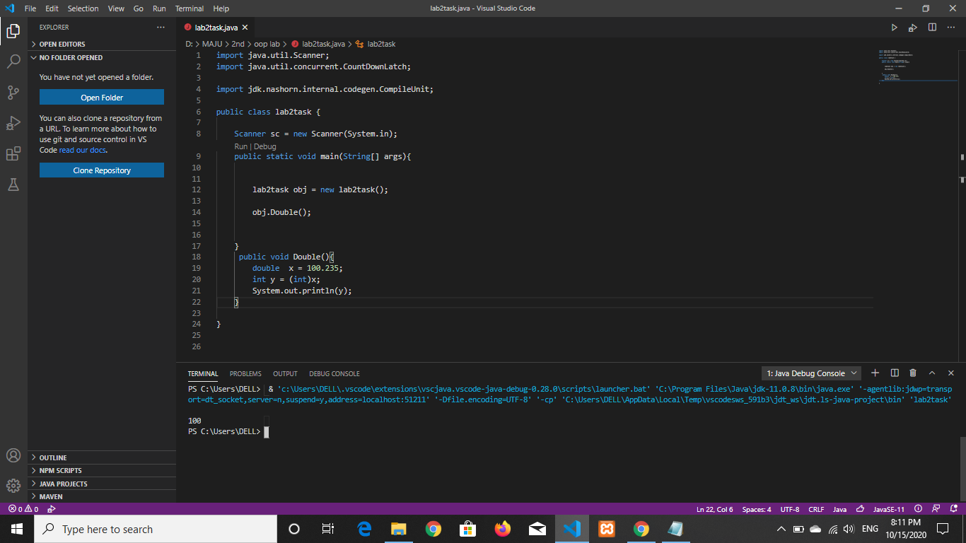

**Question 6/Task 6:**

Write a program to add 2 to the ASCII value of the character ‘c’ and print the

equivalent character.

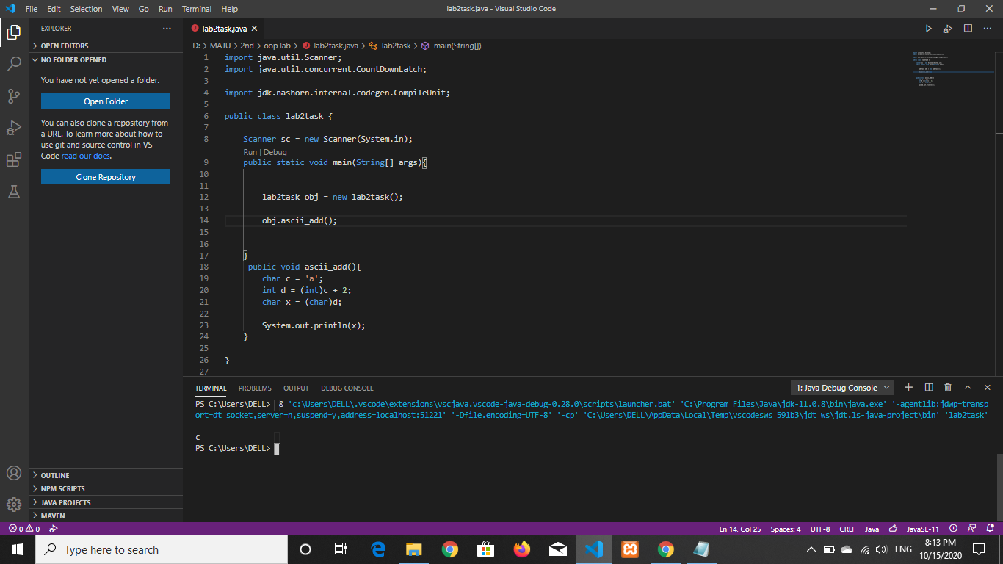

**Question 7/Task 7:**

Write a program to add an integer variable having value 5 and a double variable

having value 6.5.

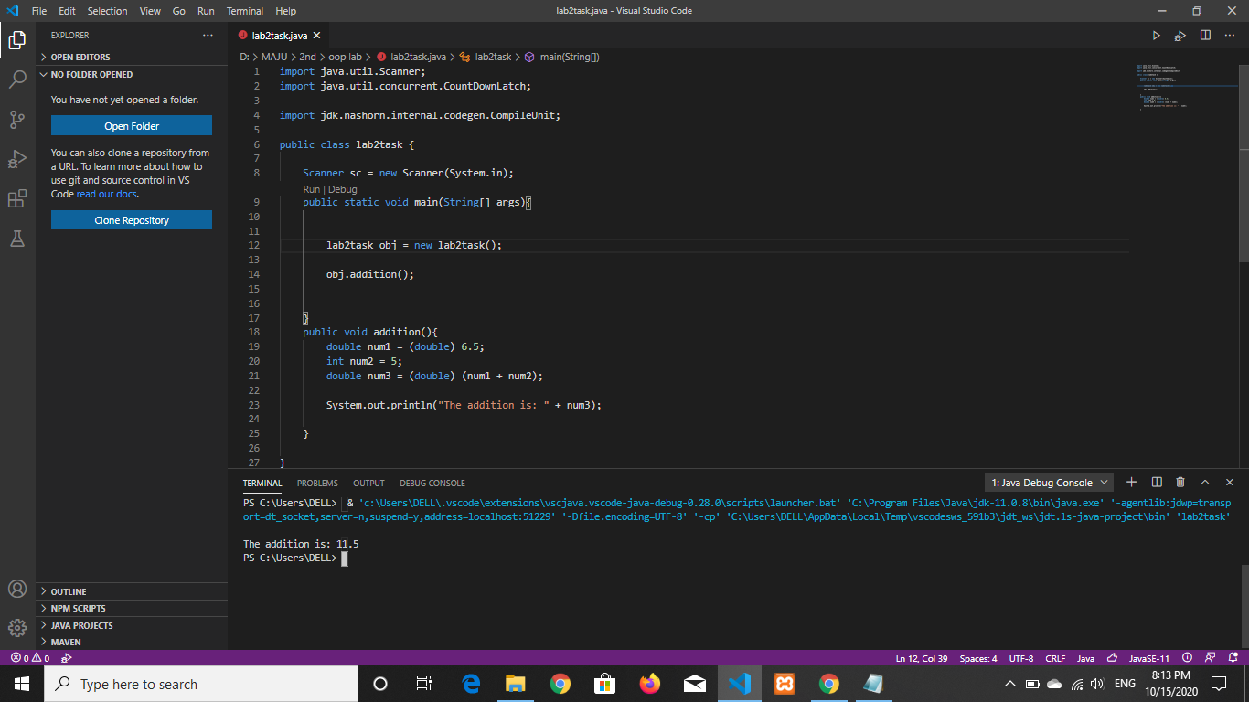

**Question 8/Task 8:**

Write a program to find the square of the number 2.9.

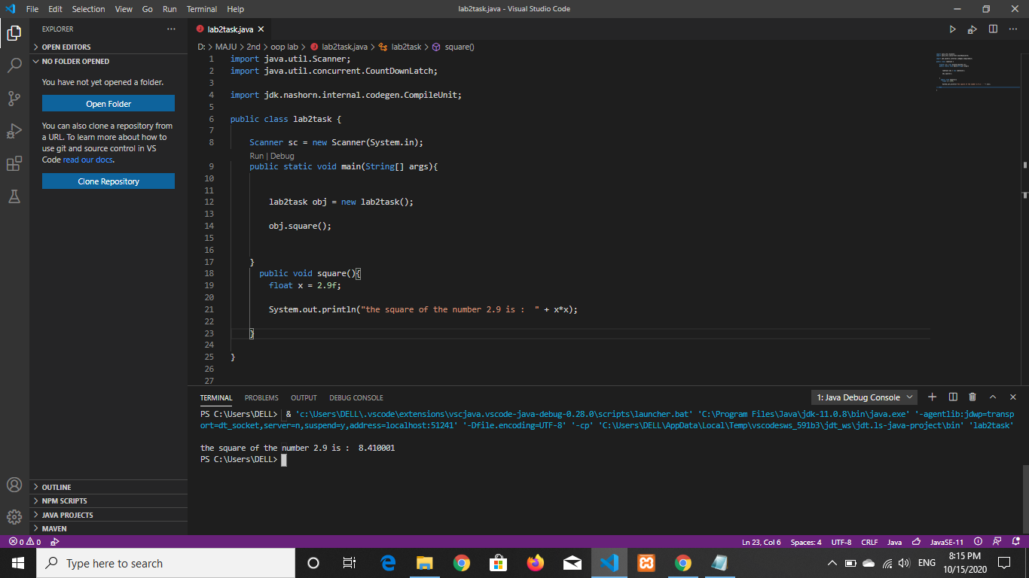

**Question 9/Task 9:**

Write a program to take two integer inputs from user and print sum and product of

them.

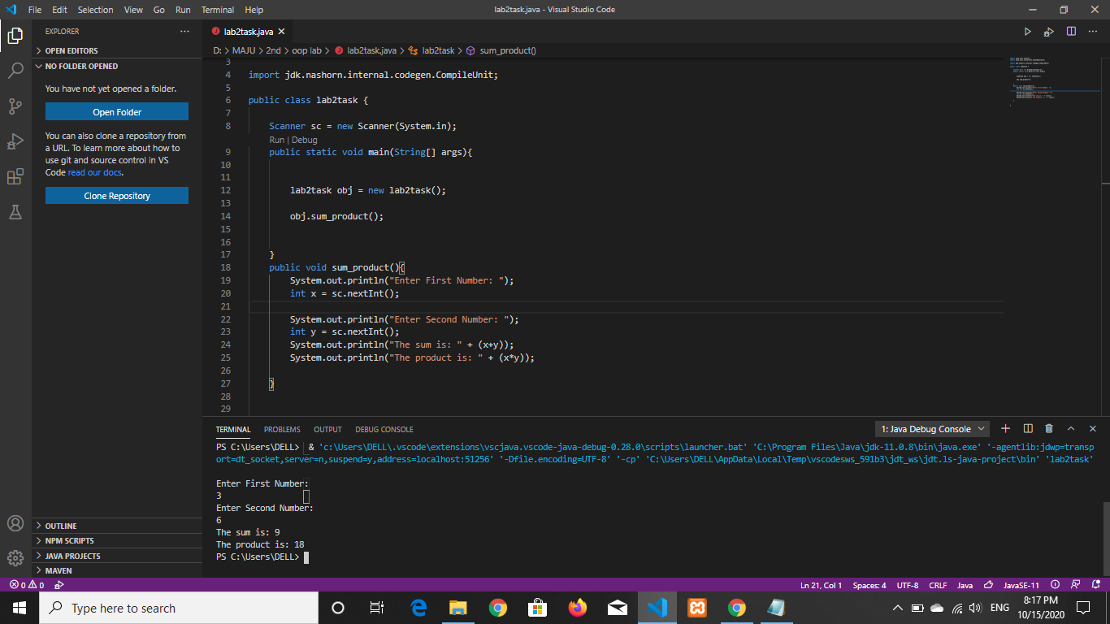

**Question 10/Task 10:**

Take two integer inputs from user. First calculate the sum of two then product of two.

Finally, print the sum and product of both obtained results.

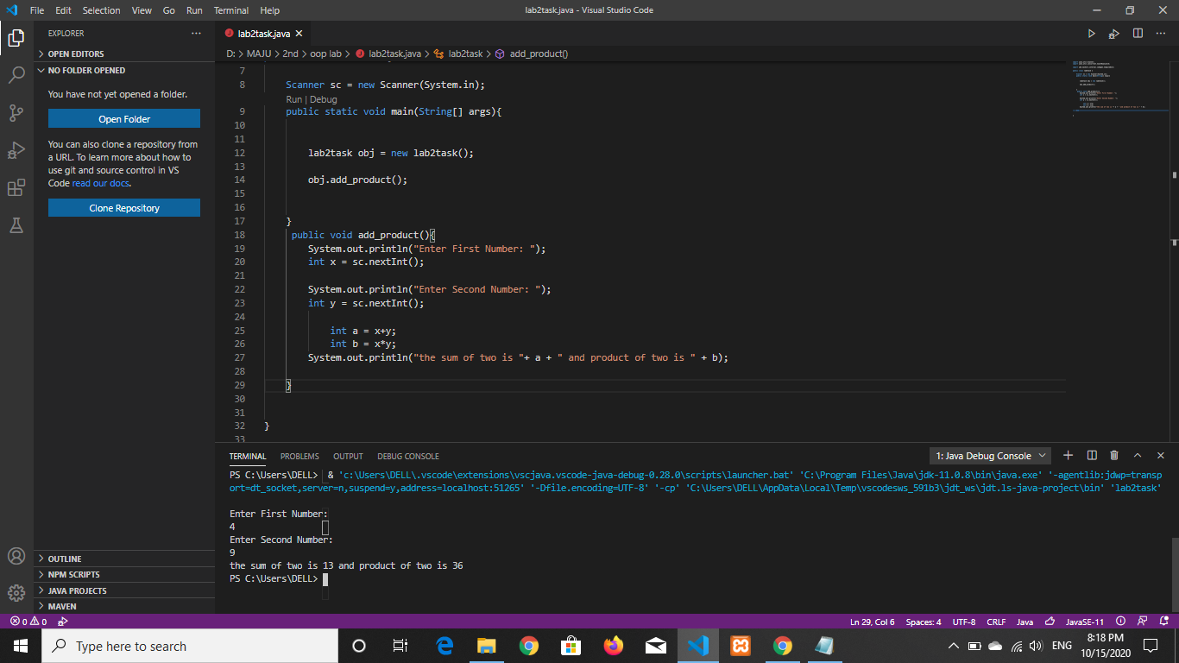

**Question 11/Task 11:**

Ask user to give two double input for length and breadth of a rectangle and print area

type casted to int.

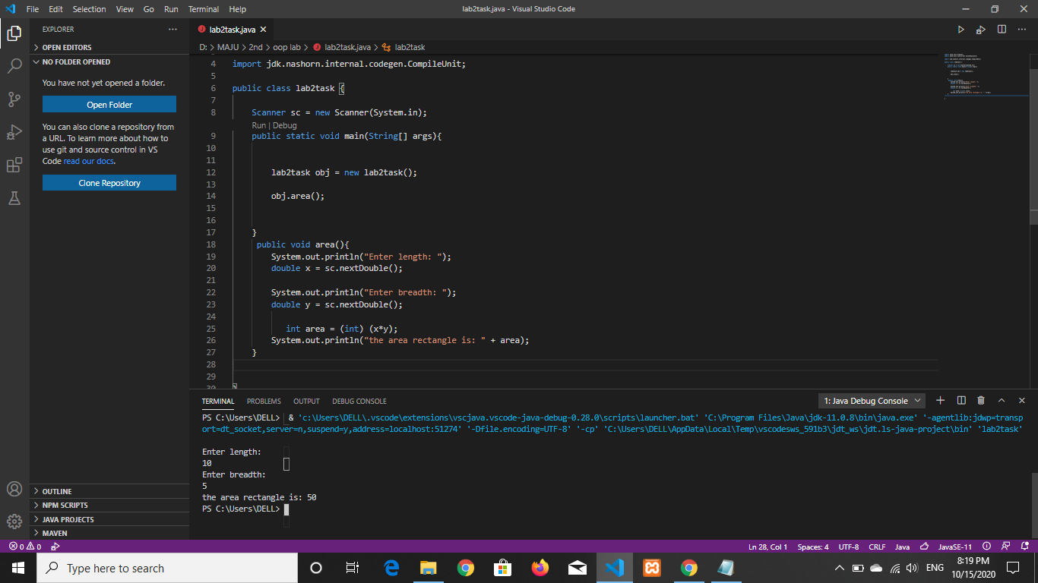

**Question 12/Task 12:**

Take name, roll number and field of interest from user and print in the format below :

**Hey, my name is xyz and my roll number is xyz. My field of interest are xyz.**

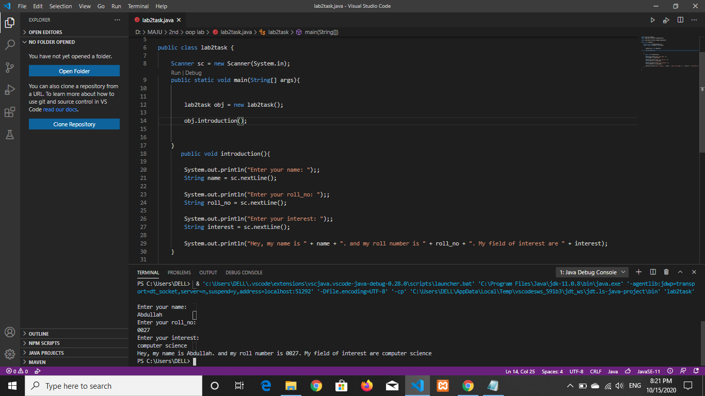

**Question 13/Task 13:**

Take side of a square from user and print area and perimeter of it.

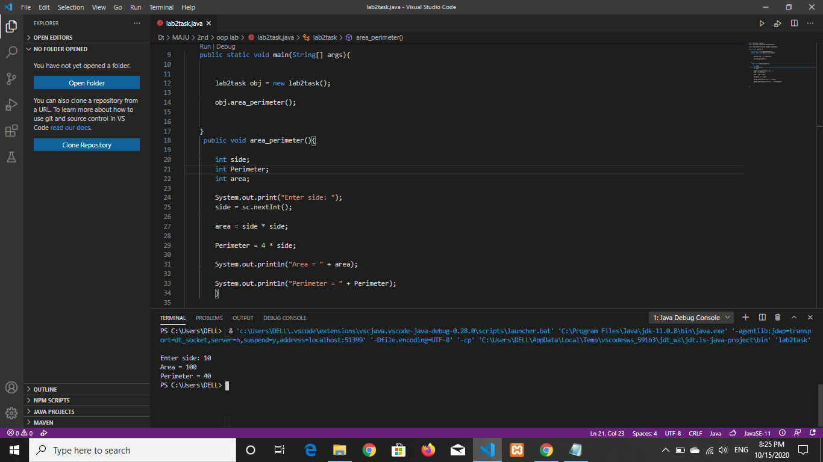

**Question 14/Task 14:**

Take two different string input and print them in same line.

E.g.:

INPUT: Hello

World

OUTPUT: HelloWorld

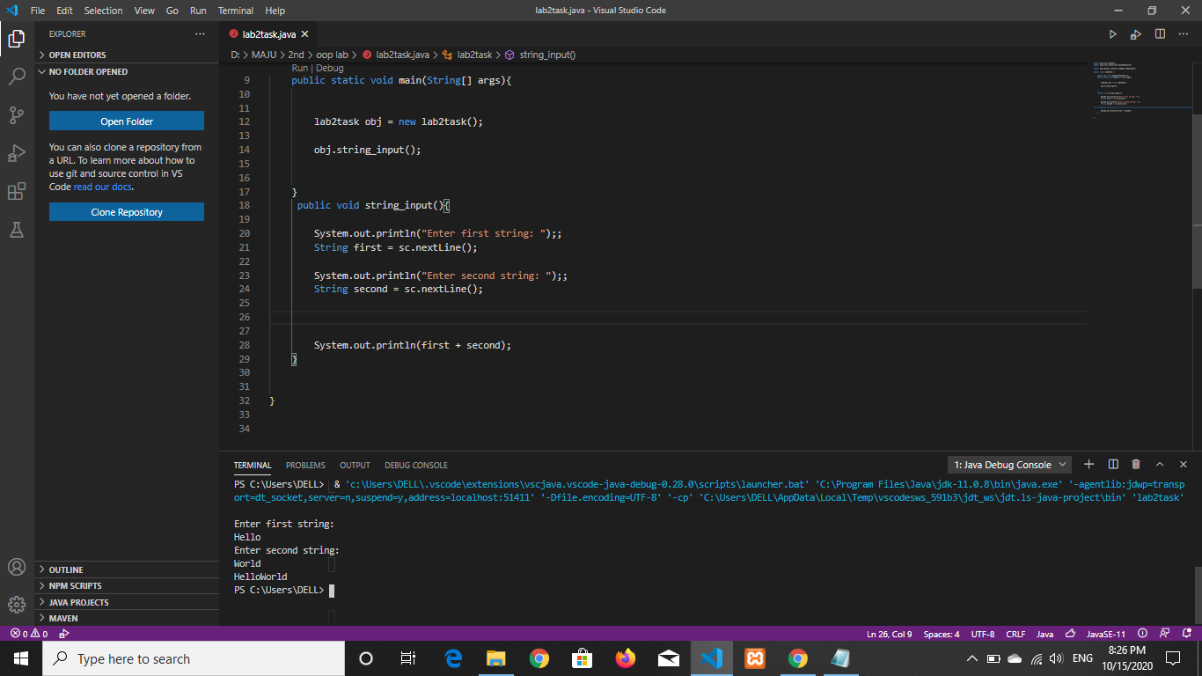

**Question 15/Task 15:**

Take 3 inputs from user and check whether:

All are equal

Any of two are equal

Hint: (&& and || )

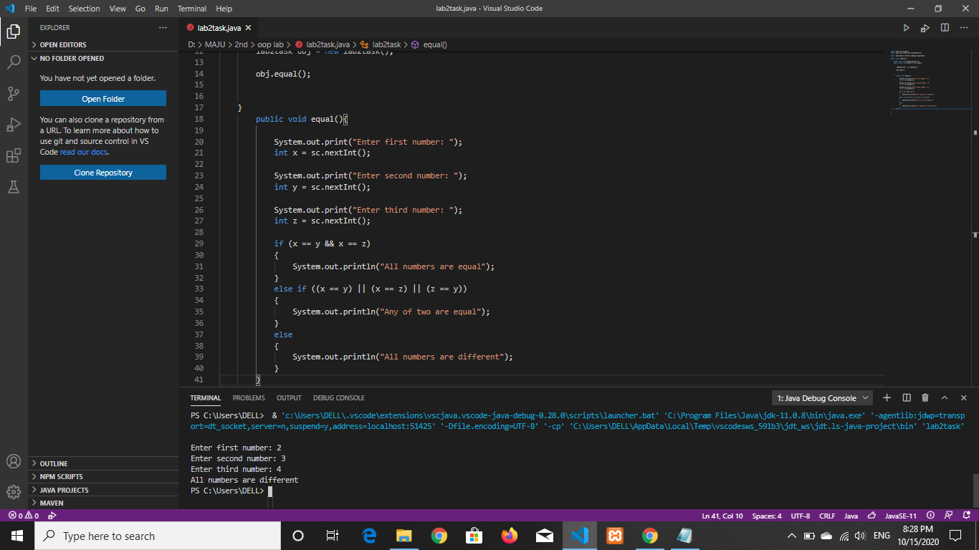

**Question 16/Task 16:**

MAJU has following rules for grading system of the PHD students:

a. Below 71 - F

b. 81 to 85 – B+

c. 86 to 89 – A-

d. 90 to 100 – A

Ask user to enter marks and print the corresponding grade.

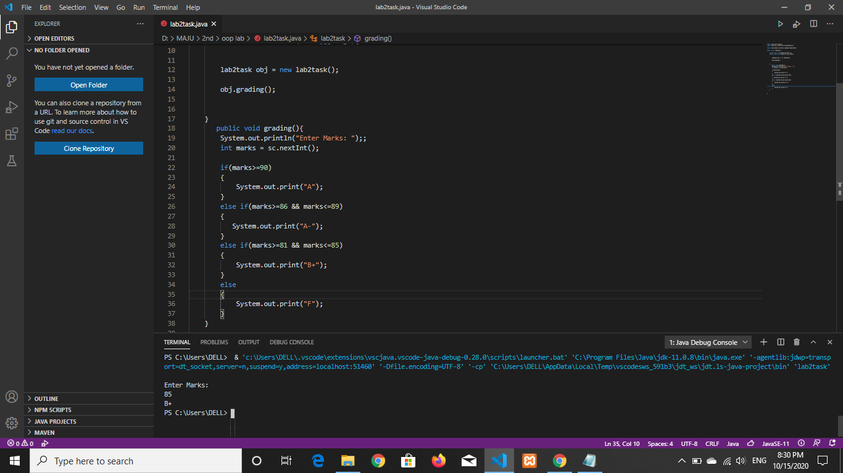

**Question 17/Task 17:**

Write a program to print absolute vlaue of a number entered by user.

E.g.

INPUT: 1        OUTPUT: 1

INPUT: -1        OUTPUT: 1

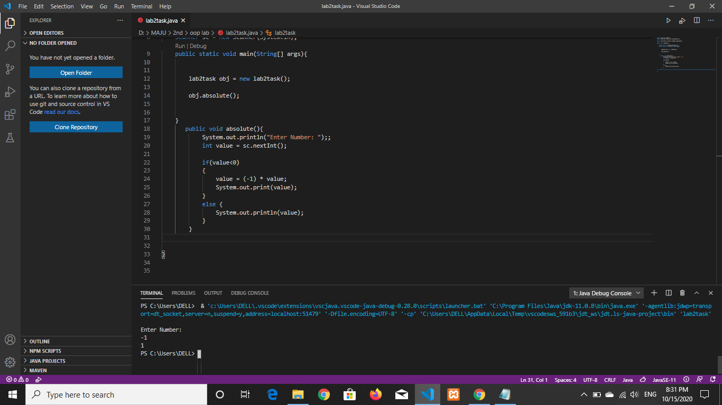

**Question 18/Task 18:**

A student will not be allowed to sit in exam if his/her attendence is less than 75%.

Take following input from user

-Number of classes held

-Number of classes attended.

And print

-percentage of class attended

-Is student is allowed to sit in exam or not.

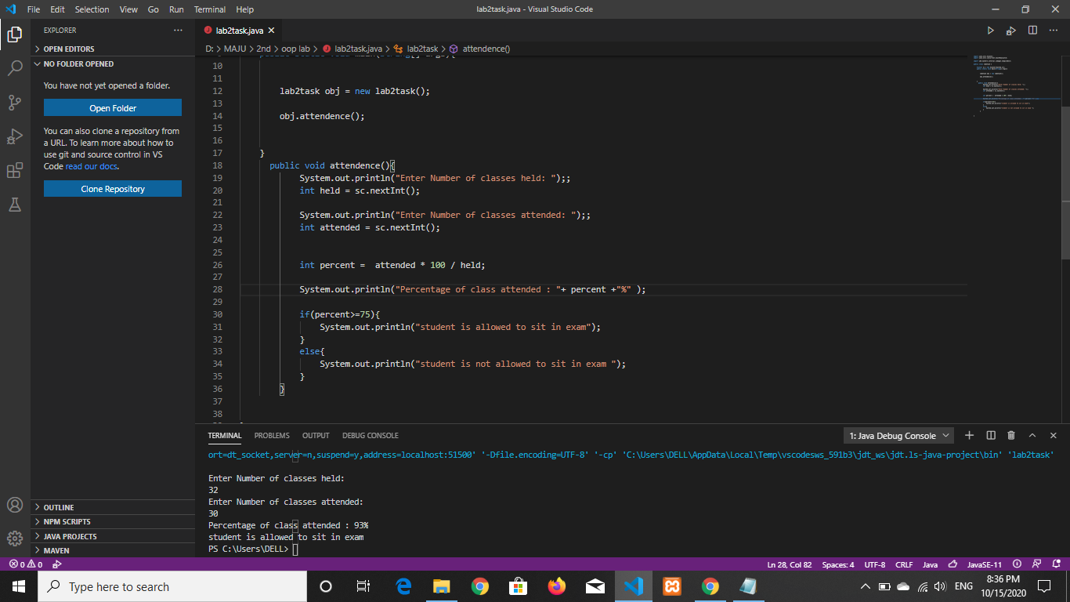

**Question 19/Task 19:**

Modify the above question to allow student to sit if he/she has medical cause. Ask

user if he/she has medical cause or not (‘Y’or ‘N’) and print accordingly.

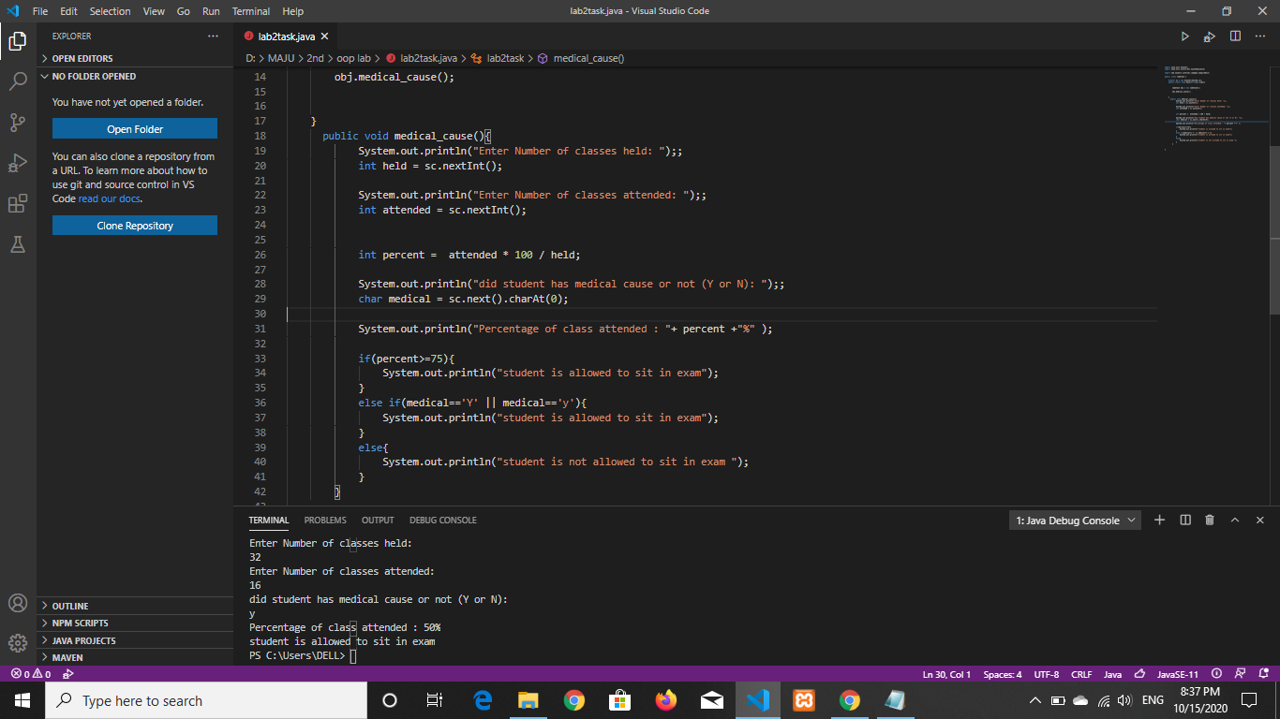

**Question 20/Task 20:**

Print ‘Working Day’ for all the days from Monday to Friday and print ‘Holiday’ for the days

Saturday &amp; Saturday respectively. (Using switch case)

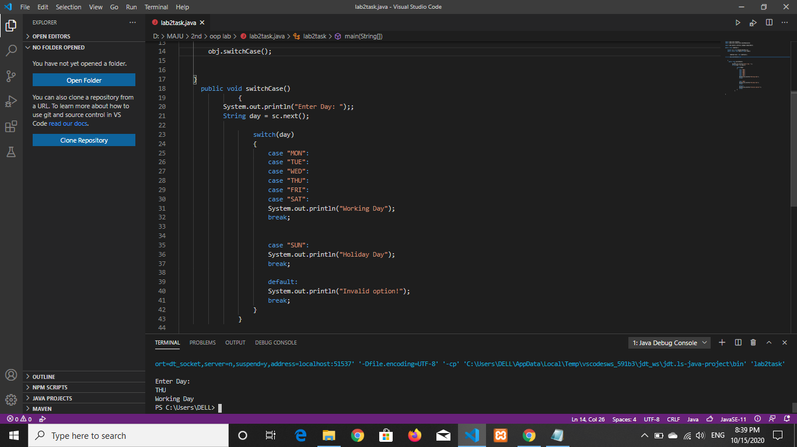

**Question 21/Task 21:**

Print ASCII values of upper case alphabets and their equivalent characters. (ASCII

value from 65 to 90).

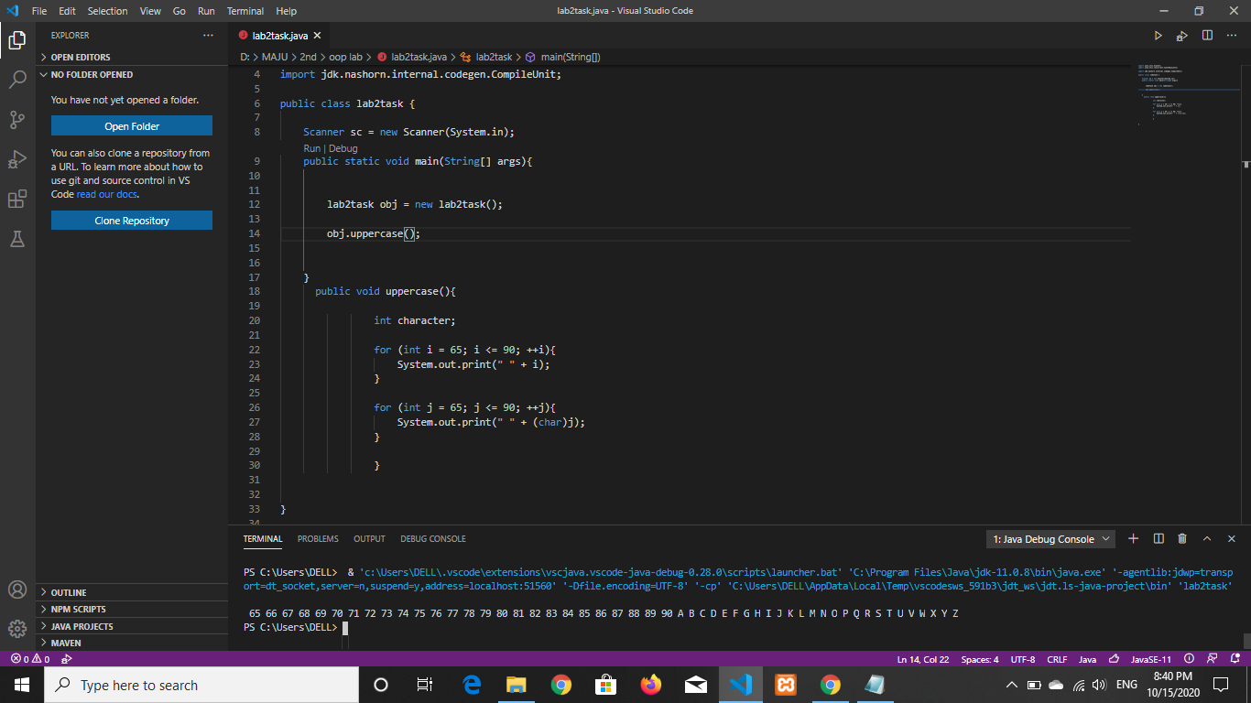

**Question 22/Task 22:**

Take integer inputs from user until he/she presses q (Ask to press q to quit after every

integer input). Print average and product of all numbers.

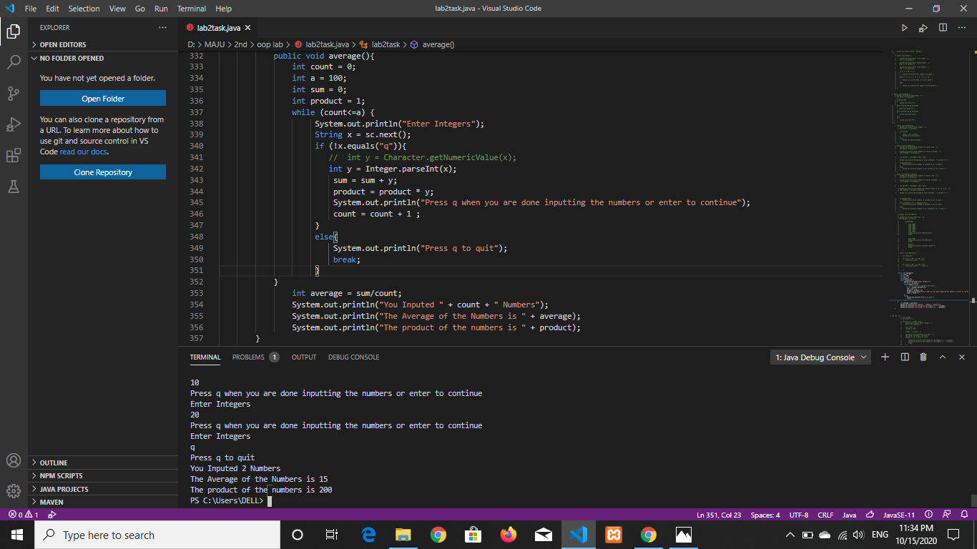

***Mohammad Ali Jinnah University***